**SSIS Conditional Flow Constraints.**

**(How to do an IF-THEN-ELSE flow like a normal flowchart)**

**Generic email with OR**

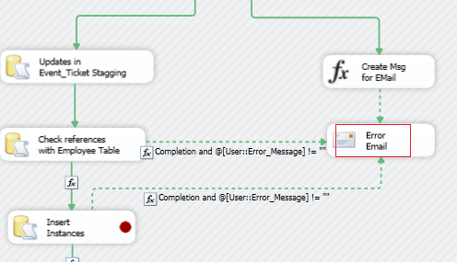

**Simple**

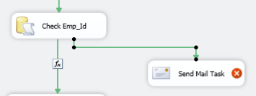

**Edit**

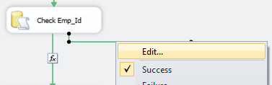

**Condition**

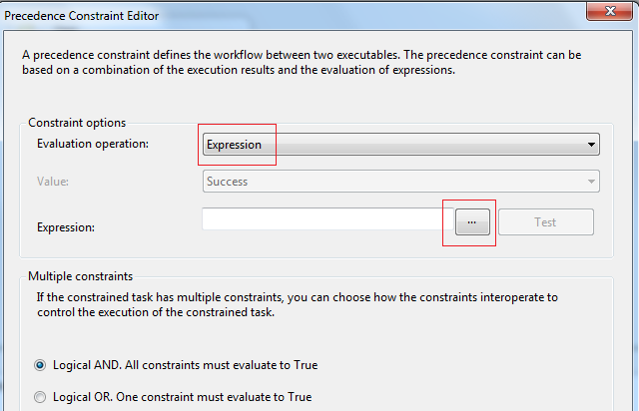

**Write Condition**

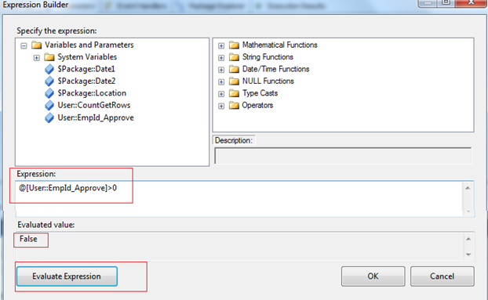

**Done**

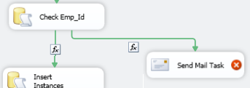

**To show the constrain**

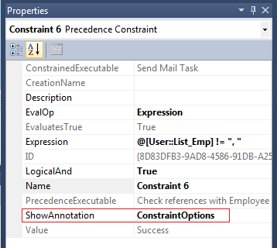



**The aim:**

* We want to run A and C always
* If a certain condition (i.e. User:Id == 1) is true then we want to run B before C.

When we run the flow below with User::Id == 1 then A runs, then B and then C, so all is fine so far. However, when we run with User:Id == 0 then A runs but C will never run because it requires B to run with success as well.

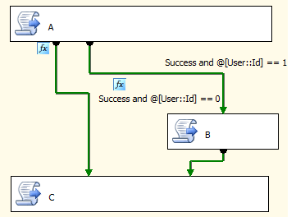

**The problem**: With the default connectors, the condition for C to run is a logical AND of the constraints/conditions of its two input connectors. When you edit one of the connectors connecting to C you will see in the Multiple Constraints section that "Logical AND" is selected. This is the problem that prevents C from running if B doesn't run as well.

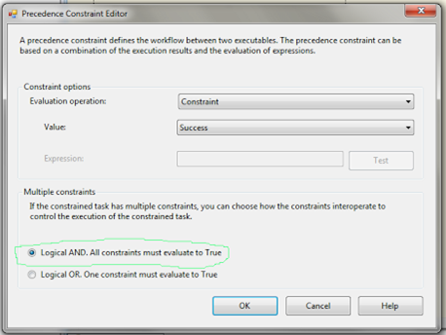

In expression: @[UserID::ID] == 1

**The solution:** Select the "Logical OR" option so that C will run if **either** of its input connectors conditions/expressions are true. This will turn both the connectors joining to C into dotted lines as shown in the figure below.

